Project Design Phase
Solution Architecture
Date | 04 October 2026
Team ID | SWTID-2026-6870
Project Name | Streamlining IT Procurement: Automating Standard Laptop Orders with Flow Designer
Maximum Marks | 4 Marks

Solution Architecture
Solution architecture bridges the gap between the business problem and the technology solution. For this project the goals are to:
- Find the best technology to remove manual effort from standard laptop procurement.
- Describe the structure and behaviour of the automation to stakeholders.
- Define the features, development phases and requirements of the solution.
- Provide the specification by which the solution is built, managed and delivered.

Solution Architecture Diagram
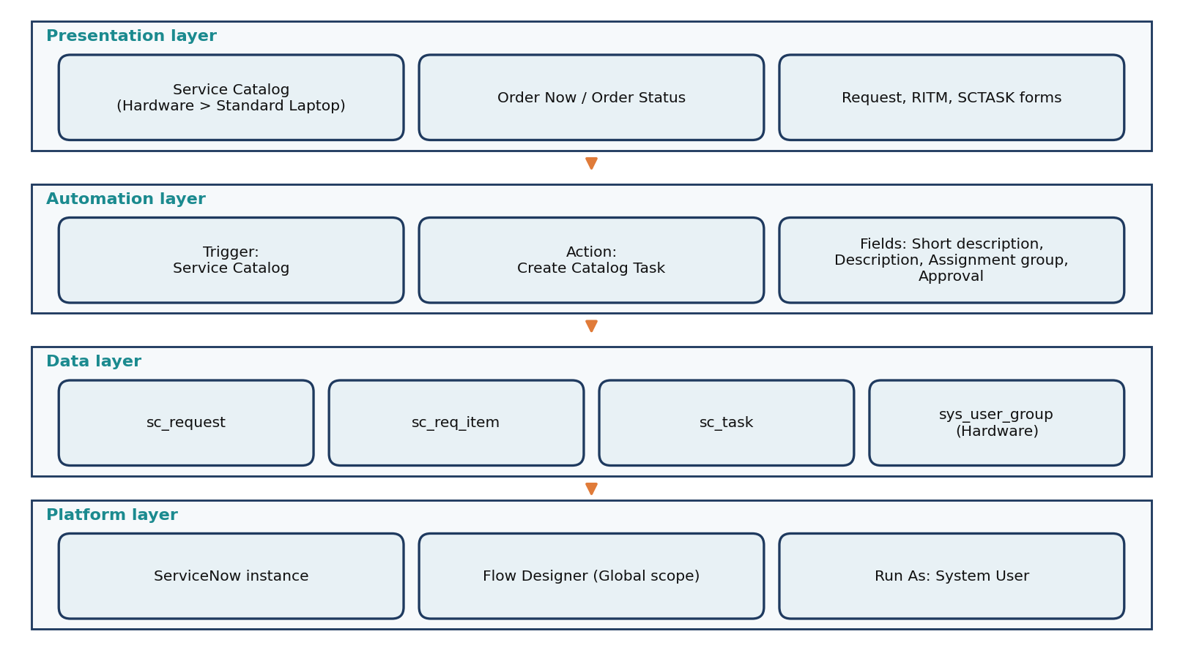
Figure 1: Layered solution architecture

Architecture and data flow
Step | Component | What happens
1 | Service Catalog | Employee opens Hardware > Standard Laptop and clicks Order Now
2 | Request / Requested Item | ServiceNow creates REQ and RITM records and shows the Order Status page
3 | Approval | The approver approves the request in the Approvers related list
4 | Flow Designer | Flow "Standard laptop task" starts through the Service Catalog trigger because it is attached to the item (Process Engine)
5 | Create Catalog Task | Action creates a record in sc_task linked to the Requested Item with short description, description, assignment group and approval values
6 | Hardware group | Task appears in the Catalog Tasks list of the RITM, assigned to Hardware, ready for configuration

